**Final Report – Fraud Transactions Analysis**

1. **Transactions per Card Holder:**
   1. The following script isolates the transactions for n specific Card Holder (as an example Card Holder with id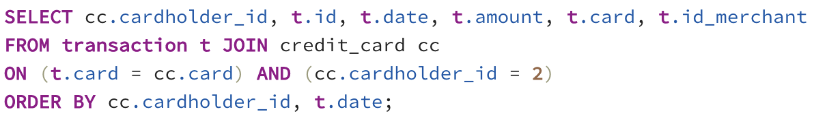

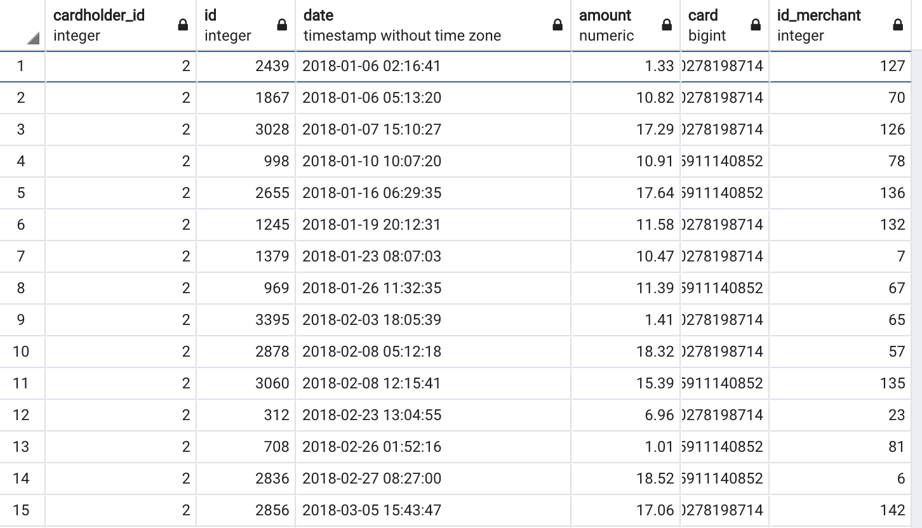

1. **Consider the time period 7:00 a.m. to 9:00 a.m.**
   1. What are the top 100 highest transactions during this time period?

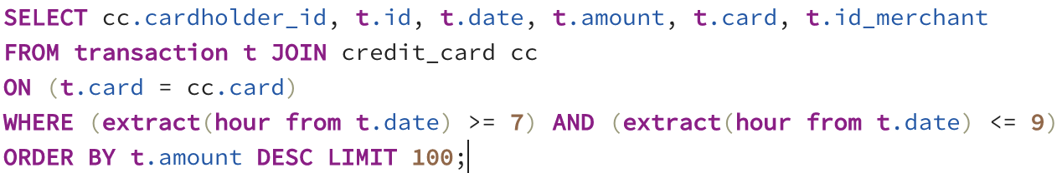

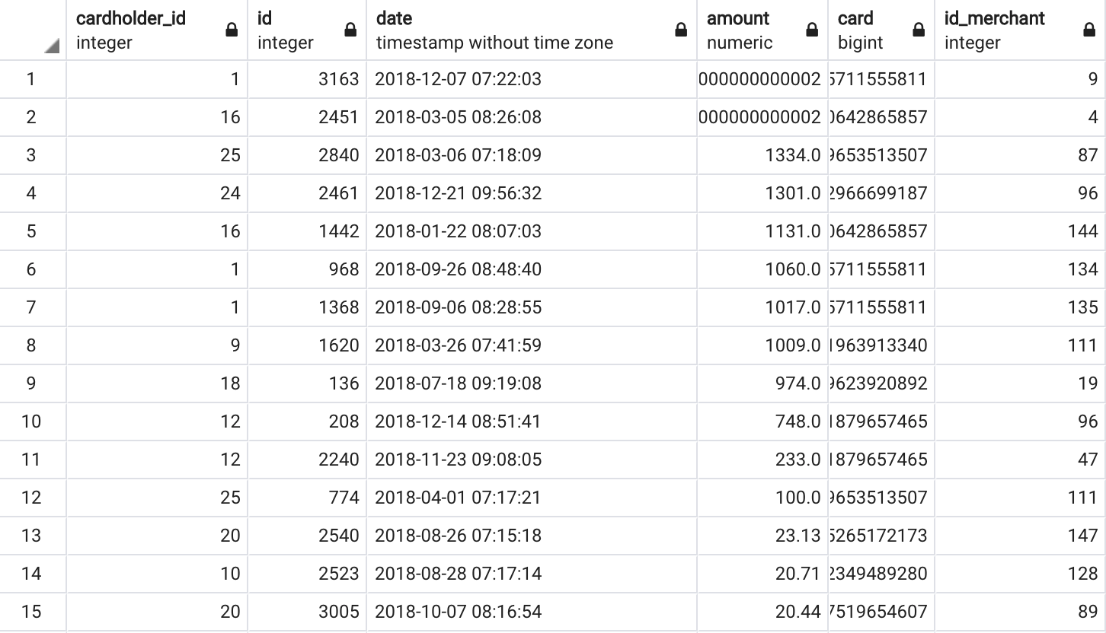

* 1. Do you see any fraudulent or anomalous transactions?

Not really, because we should compare against the trends per Card Holder. Even when we can see some very big transactions, we cannot infer that these ones are frauds.

1. **Some fraudsters hack a credit card by making several small payments (generally less than $2.00), which are typically ignored by cardholders.** 
   1. Count the transactions that are less than $2.00 per cardholder. Is there any evidence to suggest that a credit card has been hacked? Explain your rationale.

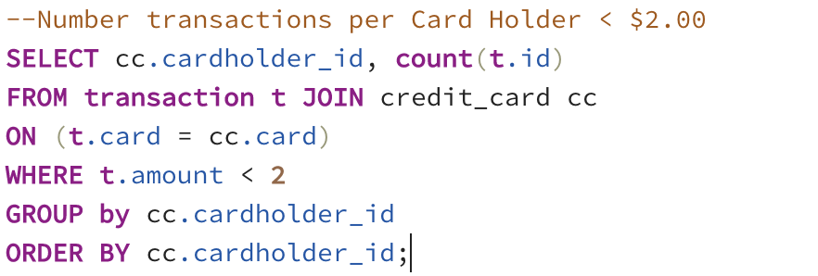

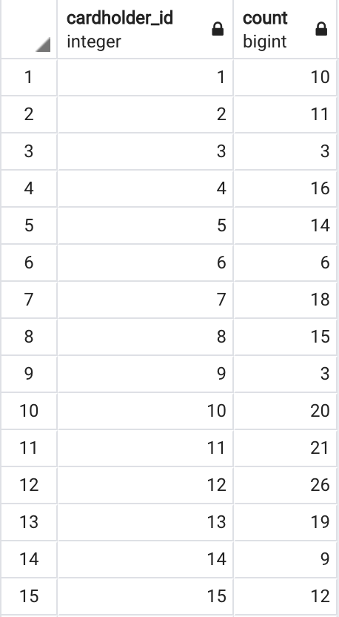

Even when we can see a number of transactions < $2.00, it doesn’t mean that these are signals of fraud. Again, we should analyze case by case to see what is the behavior per Card Holder.

1. **What are the top 5 merchants prone to being hacked using small transactions?**

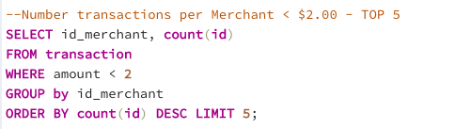

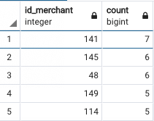

1. **Once you have a query that can be reused, create a view for each of the previous queries.**

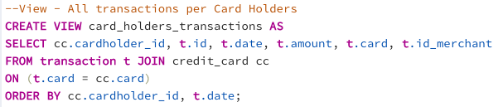

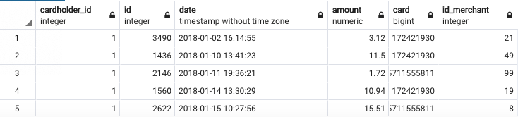

1. **Report for Fraudulent Transactions:**
   1. Verify if there are any fraudulent transactions in the history of two of the most important customers of the firm. For privacy reasons, you only know that their cardholders' IDs are 18 and 2.

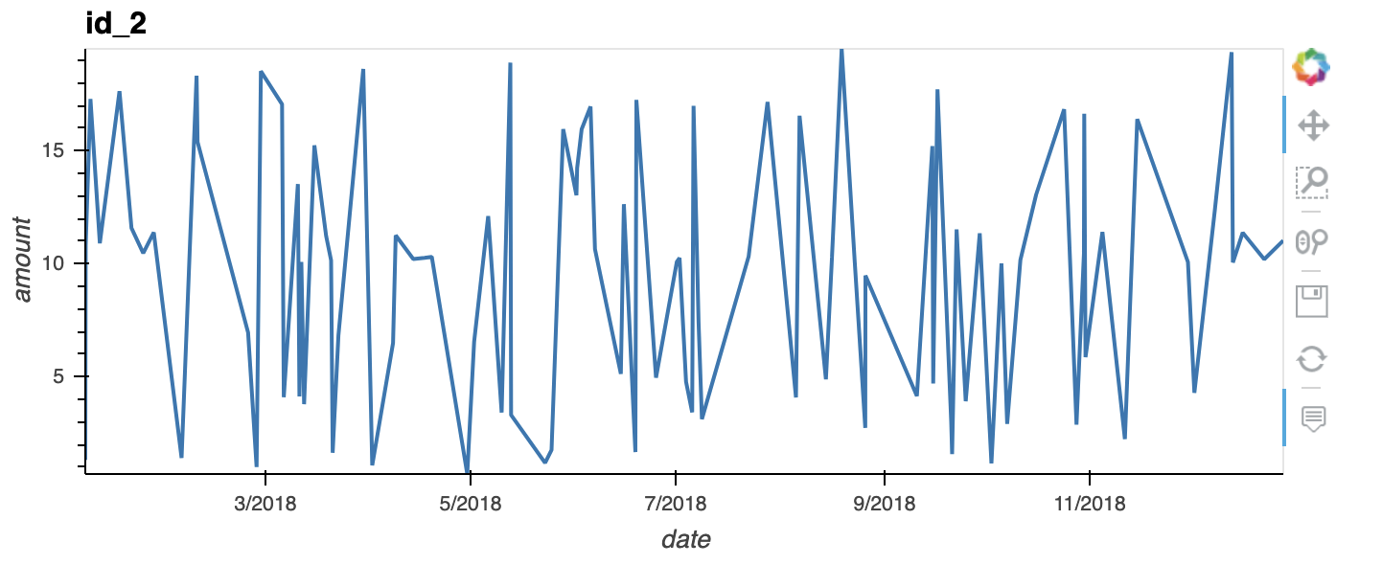

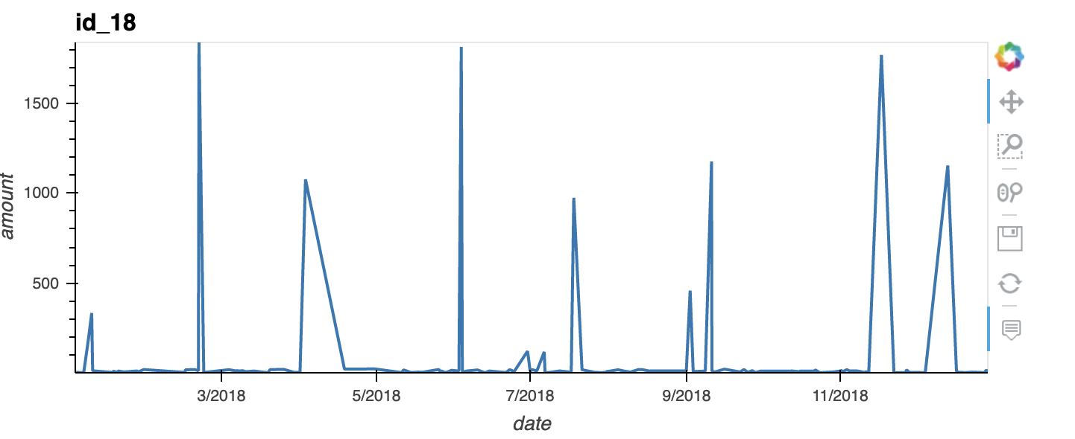

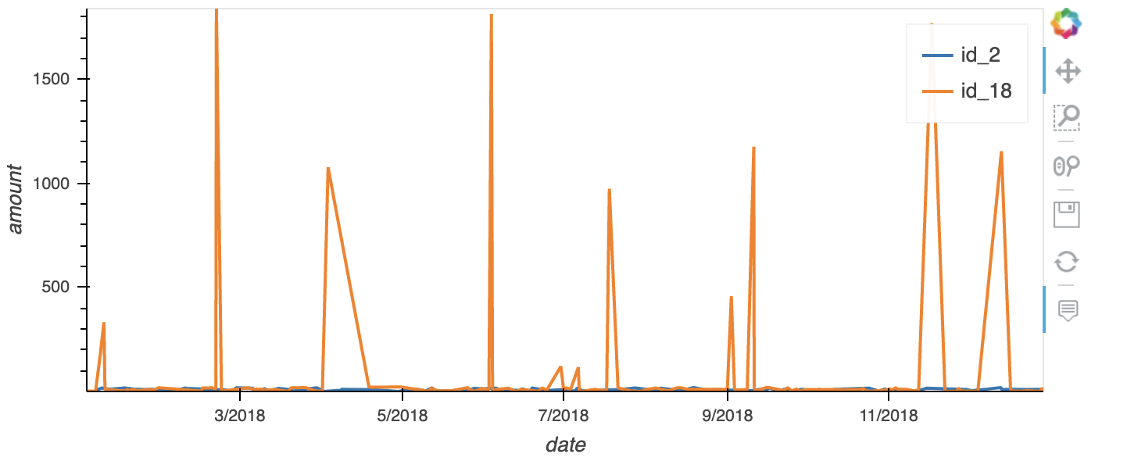

**I think both Card Holders with ids 2 and 18 have a pretty stable consumption patterns for the most of the dates with small amounts most of the time, but in some dates, we can see that Card Holder with id 18 has really higher charges. This situation for Card Holder id 18 should be investigated to realize if those are really signals of frauds or simply that Card Holder has had extraordinary spends during the observed dates.**

* 1. The CEO of the biggest customer of the firm suspects that someone has used her corporate credit card without authorization in the first quarter of 2018 to pay quite expensive restaurant bills. You are asked to find any anomalous transactions during that period.

Using Plotly Express, create a series of six box plots, one for each month, in order to identify how many outliers per month for cardholder ID 25.

Do you notice any anomalies? Describe your observations and conclusions.

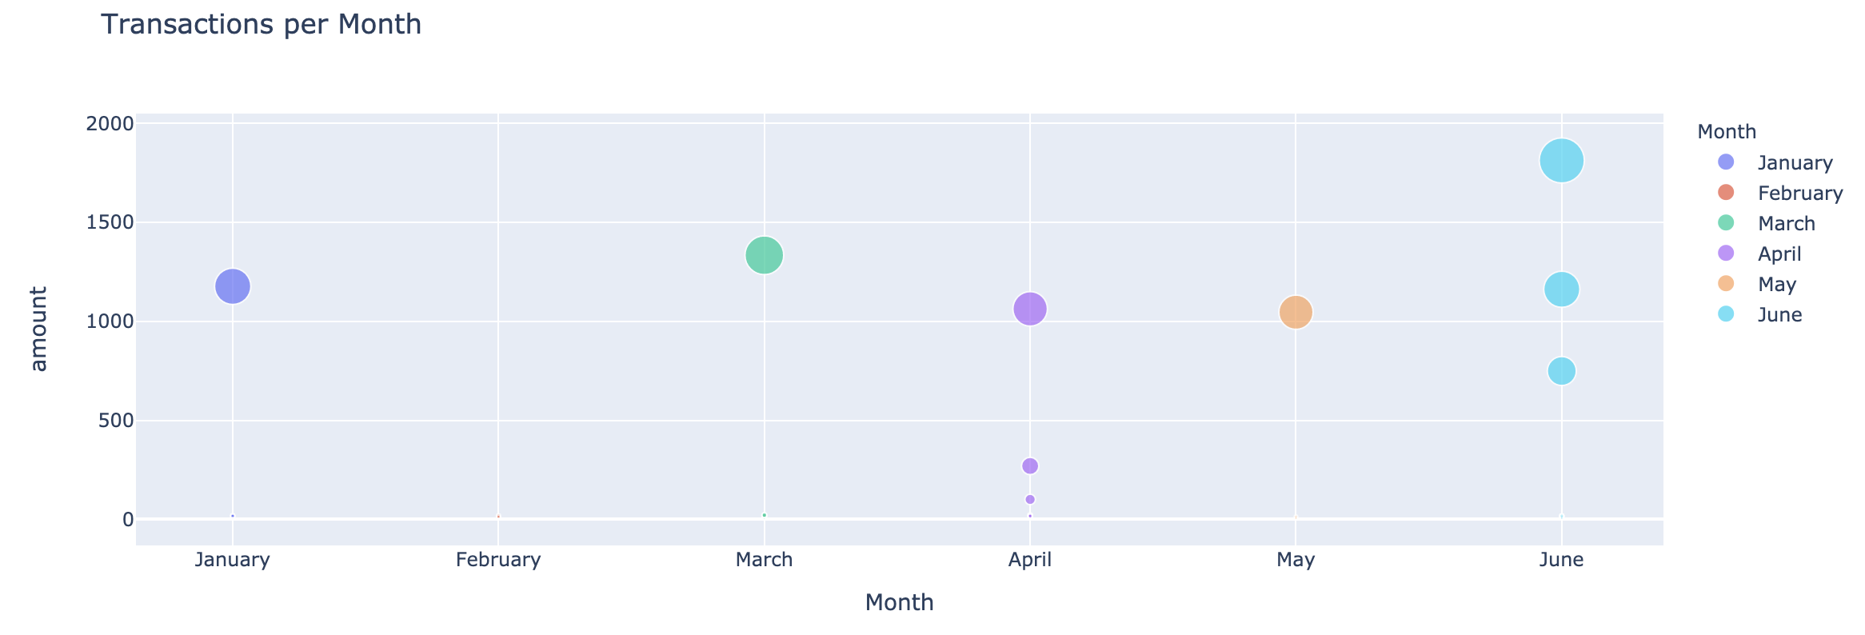

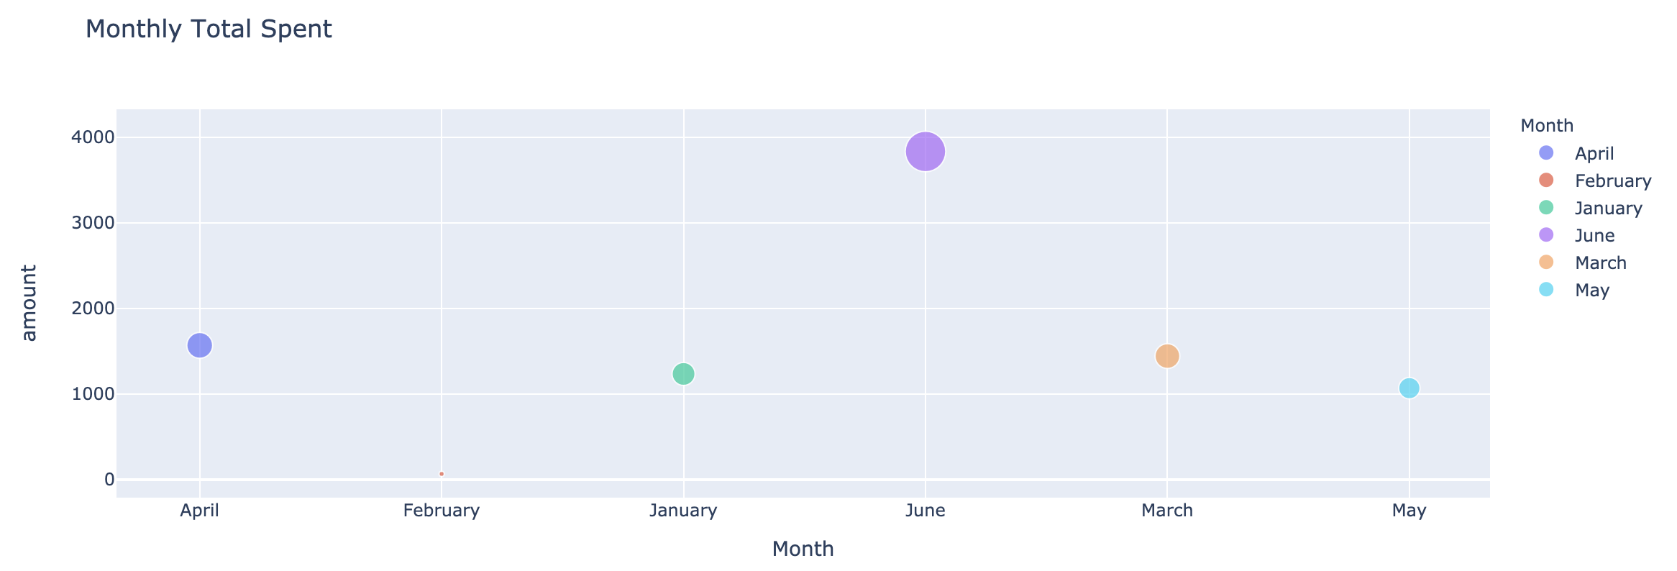

**As we can see, there are some high charges for Card Holder id 25 during the six months, but especially in June we can see a much higher spend. That could be a signal of fraud, thus it should be investigated and checked with the Card Holder/CEO.**

1. **DB ERD:**

